<html>
<head>
<title>menu stuff</title>

<style type="text/css">
.menu{display:none;margin-left:20px}
</style>

<script type="text/javascript" language="javascript">
<!--
function togglemenu(currmenu) {
if (document.getElementById) {
thismenu = document.getElementById(currmenu).style;
if (thismenu.display == "block") {
thismenu.display = "none";
}
else {
thismenu.display = "block";
}
return false;
}
else {
return true;
}
}
// -->
</script>
</head>

<body>
<h1>jeffrey parker</h1>

<div id="mymenu">
<!-- MENU 1 -->
<a href="page1.html" onclick="return togglemenu('menu1')">sports</a>
<span class="menu" id="menu1">
<a href = "http://www.nsmb.com">biking</a><br>
<a href = "http://whistlerblackcomb.com">snowboarding</a><br>
</span>

<!-- MENU 2 -->
<br><a href="page2.html" onclick="return togglemenu('menu2')">interests</a>
<span class="menu" id="menu2">
<a href = "http://www.openoffice.org/product/draw.html">drawing</a><br>
<a href = "http://www.ltolstoy.com">reading</a><br>
</span>

<!-- MENU 3 -->
<br><a href="page3.html" onclick="return togglemenu('menu3')">pictures</a>
<span class="menu" id="menu3">
<a href = "http://www.collegeparkbaptist.org/images/jeff2.jpg">musical jeffrey</a><br>
<a href = "http://www.geocities.com/Area51/5341/jeff.jpg">tough jeffrey</a><br>
</span>
</div>
</body>
</html>
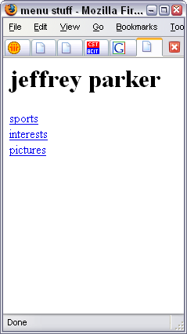 | 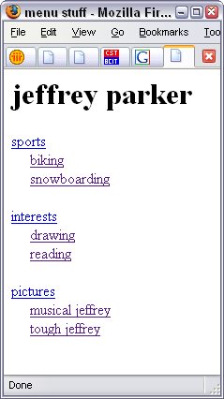
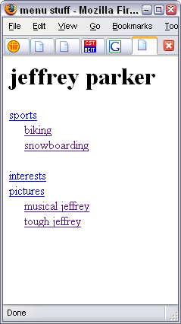 | 